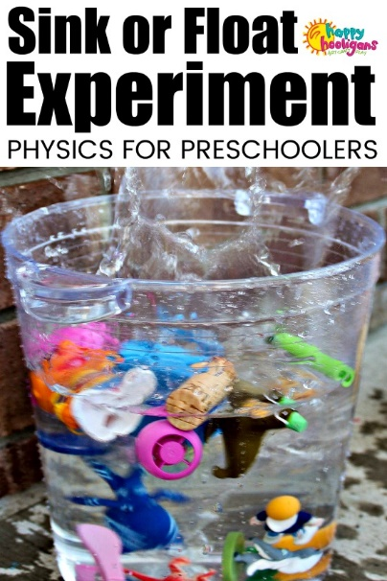

A great experiment for Indoors or Outdoors. Indoors, children can do this activity at the kitchen sink, in the bathtub or on the floor with a tub or basin filled with water.

Try adding some food colouring and liquid scents or a packet of jelly powder to the water. Not only does this colour the water, it gives it a wonderfully fruity scent.

The children get a thrill out of watching the water change colour and the pop of colour and the scent have educational benefits as well : children retain more information when more than one sense is engaged.
What you will need:
- waterproof toys and household items (see suggested items below)
- a container to do the experiment in i.e. plastic tub, basin, pot, bucket etc.
- drinking straws (optional)
- Food colouring, liquid scents and Jelly crystals (optional)
Suggested items for a Sink or Float experiment:
Items that sink
- metal utensils
- coins
- stones
- toy car/truck
- keys
- glass gemstones or marbles (not suitable for toddlers)
Items that float:
- Duplo/Lego
- stick or popsicle stick
- corks
- bathtub toys
- foam shapes
- crayon
- rubber ball
Start off by collecting the items for your experiment. If you give your children a list of things to collect, this part of the activity can be a fun scavenger hunt.
Fill a tub or bucket with lukewarm water. If colouring your water, you can add it now or once the toys have been added.
Before adding your objects to the water, ask your children to predict which objects they think will sink and which will float. Now, have the children drop the objects, one by one, into the water and observe what happens.
Once all of the items are in the water, you can extend the activity by giving the children drinking straws to blow the floating items around. This is a fun way to teach children about kinetic energy as the air they blow through the straw propels the floating items forward.
Before explaining why items sink or float, ask your children why they think an object sinks or floats. Once you have prompted their learning by explaining the science behind the activity, allow your children to replicate the experiment as many times as they please. This will help to consolidate their knowledge and reap the benefits of play-based learning.

