Big Garden Birdwatch
Join us 29th – 31st January

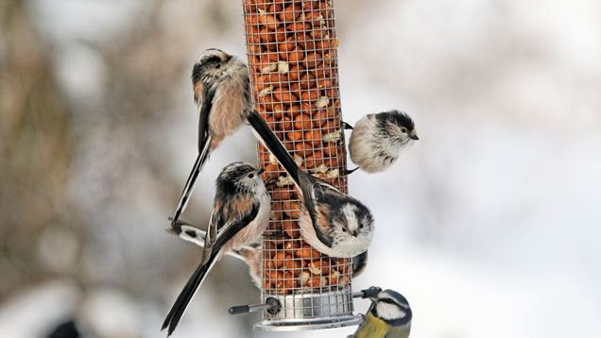

Why not take the opportunity to get some fresh air in your garden this weekend and help our wildlife, by joining in with the annual RSPB Big Garden Birdwatch?

Taking Part in Big Garden Birdwatch - RSPB

